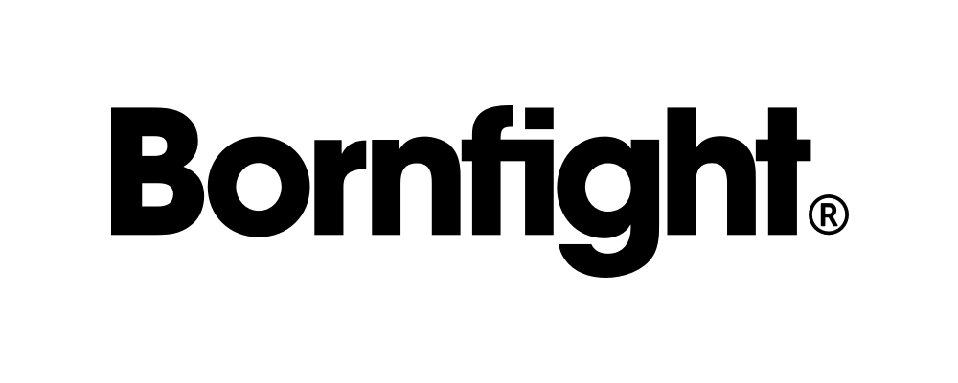
JUNIOR PROJECT MANAGER (M/F)

Place of employment: Zagreb, Croatia. Application due date: July 25, 2019
This is the part where companies usually write a short intro about their values and culture, but we won’t write about it. We have a video!
Now back to the main topic.
WE’RE HIRING A JUNIOR PROJECT MANAGER
In their own words, the mission of our Project Management department is to have complete control over the information and the space-time continuum. As our team keeps growing and our clients keep needing more technologically advanced applications, tools and digital products, the amount of information, space and time that needs to be controlled grows as well. That is why we decided to add a new Junior Project Manager to the team.
We're looking for a person who's interested in tech and business, and willing to constantly learn about various industries. So, if you usually describe yourself as strict but also adaptable, and you believe you can manage multiple projects, people, resources, assets and time, then we believe you could easily fit into our Project Management team and we would love to see your CV!
JOB REQUIREMENTS:
BA and/or MA degree (students close to graduation may also apply)
At least one year of experience in the IT industry (preferably in a project management role)
Excellent knowledge of Croatian (C1) and English (B2) language, both written and spoken
Basic knowledge of development methodologies (primarily agile/scrum) and project life cycle
Familiarity with cross device/platform/browser technologies
Adaptability to new tools and procedures
A solution-oriented mindset and a team player attitude
Self-organization & project-handling ability
A knack for communicating & presenting

YOU GET EXTRA POINTS FOR:
Experience in managing/leading projects
Technical knowledge of development
Certifications in the field of project management or organization (preferably agile/scrum)
Basic risk/crisis management skills

HERE’S WHAT YOU’LL DO:
Manage small and medium-sized projects for local and international clients
Define project scope, timeline and budget
Write and edit documentation
Communicate with clients - define requirements, report and educate
Define and update weekly production plans
Cooperate with members of the Project Management team and production departments

IF YOU GET THE JOB, YOU’LL ALSO GET:
Awesome team buildings, dog-friendly office, in-office gym, rec room and game room
Lots of internal educations from your colleagues & external educations from industry experts
Access to a variety of industry-related books, magazines and additional reading materials
Monthly one-on-one meetings with team leader and structured biannual meetings about personal development
"Time In" counseling sessions with team psychologist about personal motivation, work-life balance, satisfaction & performance (optional & available for all)
Flexible working hours
A Macbook, an extra monitor and a smartphone
Parking spaces for rent in the office building garage and secure storage for bikes

READY TO APPLY? JUST SEND US THESE FILES:

Your CV
Your motivational letter or video (tell us why you want to join us)

Submit your application in Croatian and/or English by clicking the link: https://www.bornfight.com/careers/junior-project-manager/

